- Install and configure Tailwind in the React app.
Step 1: Install Tailwind packages
Open terminal in your React project and run:
npm install tailwindcss @tailwindcss/vite

Step 2: Update vite.config.js:
Open vite.config.js
import { defineConfig } from 'vite'
import react from '@vitejs/plugin-react'
import tailwindcss from '@tailwindcss/vite'
export default defineConfig({
plugins: [
react(),
tailwindcss(),
],
})

Step 3: Add Tailwind import
Open src/index.css
@import "tailwindcss";

- Style a `Card` component using spacing, typography, and border utilities.
Coding:
function Card() {
return (
<div className="flex justify-center items-center h-screen">
<div className="max-w-sm p-6 bg-green-200 rounded-2xl shadow-2xl border border-gray-200 text-center">

<img
src="https://picsum.photos/400/200"
alt="card"
className="rounded-xl mb-4"
/>

<h2 className="text-2xl font-bold text-black mb-2">
Shanmuga priyan
</h2>

<p className="text-black leading-relaxed mb-4">
Id : 230282601112
</p>

<button className="bg-blue-500 text-white px-4 py-2 rounded-lg hover:bg-blue-600">
Read More
</button>

</div>
</div>
)
}

export default Card
Output:
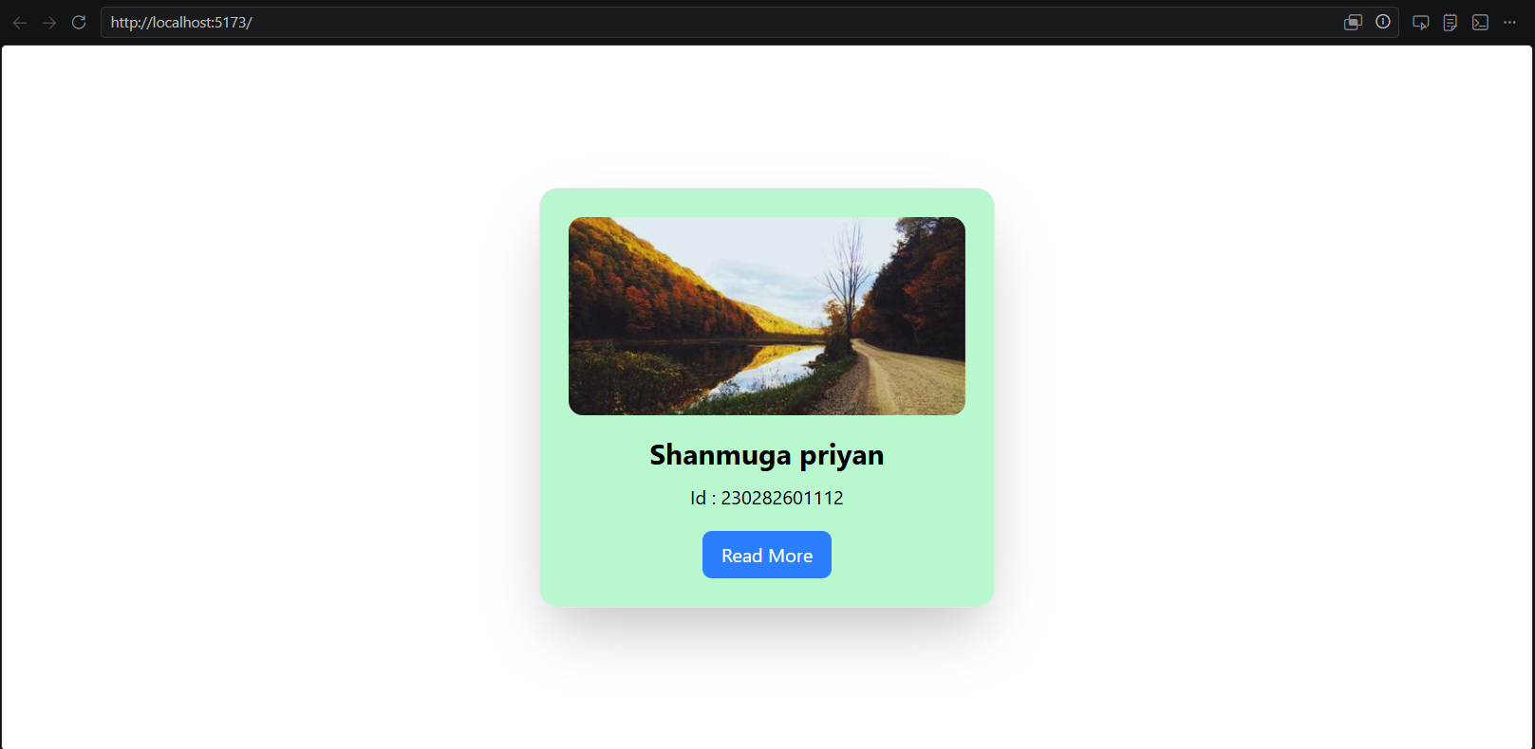
- Create a responsive navbar using Flexbox/Grid utilities and breakpoints.
Coding:
function Navbar() {
return (
<nav className="bg-gray-900 text-white px-6 py-4">

<div className="max-w-6xl mx-auto flex flex-col md:flex-row md:justify-between md:items-center">

<h1 className="text-2xl font-bold mb-4 md:mb-0">
MyApp
</h1>
<ul className="flex flex-col gap-3 md:flex-row md:gap-6">
<li><a href="#" className="hover:text-blue-400">Home</a></li>
<li><a href="#" className="hover:text-blue-400">About</a></li>
<li><a href="#" className="hover:text-blue-400">Services</a></li>
<li><a href="#" className="hover:text-blue-400">Contact</a></li>
</ul>

</div>

</nav>
)
}

export default Navbar
Output:
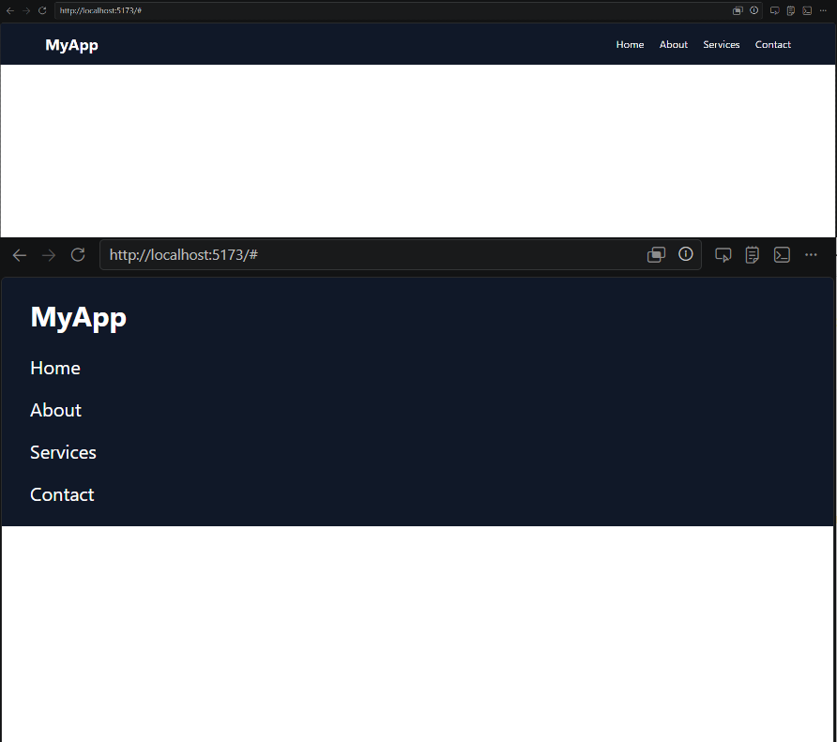
- Build a button group with hover/focus/active states via utilities.
Coding:
function ButtonGroup() {
return (
<div className="flex gap-4 m-10">

<button
className="
px-5 py-2 rounded-lg bg-blue-500 text-white
hover:bg-blue-600
focus:outline-none focus:ring-4 focus:ring-blue-300
active:scale-95
transition
"
>
Save
</button>

<button
className="
px-5 py-2 rounded-lg bg-red-500 text-white
hover:bg-red-600
focus:outline-none focus:ring-4 focus:ring-red-300
active:scale-95
transition
"
>
Delete
</button>

</div>
)
}

export default ButtonGroup

Output:
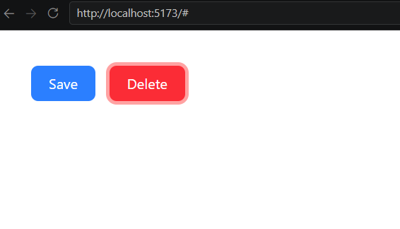
- Extract common Tailwind class sets into small component props for reuse.
Coding:
ReuseableComponents.jsx:
function ReuseableComponents({ children, variant = "primary" }) {

// Common classes
const baseClasses =
"px-4 py-2 rounded-lg font-semibold transition"

// Different styles
const variants = {
primary:
"bg-blue-500 text-white hover:bg-blue-600",

danger:
"bg-red-500 text-white hover:bg-red-600",

success:
"bg-green-500 text-white hover:bg-green-600",
}

return (
<button className={`${baseClasses} ${variants[variant]}`}>
{children}
</button>
)
}

export default ReuseableComponents
App.jsx:
import { useState } from 'react'
import reactLogo from './assets/react.svg'
import viteLogo from './assets/vite.svg'
import heroImg from './assets/hero.png'
import './App.css'
import Card from './Card'
import Navbar from './Navbar'
import ButtonGroup from './ButtonGroup'
import ReuseableComponents from './ReuseableComponents'

function App() {

return (
<div className="flex gap-4 p-10">

<ReuseableComponents variant="primary">
Login
</ReuseableComponents>

<ReuseableComponents variant="danger">
Delete
</ReuseableComponents>

<ReuseableComponents variant="success">
Submit
</ReuseableComponents>

</div>
)
}

export default App

Output:
